**Ideation Phase**

**Brainstorm & Idea Prioritization**

|  |  |
| --- | --- |
| Date | 19-02-2026 |
| Team ID | LTVIP2026TMIDS66321 |
| Project Name | Cafeteria Menu Display |
| Maximum Marks | 4 Marks |

**Brainstorm & Idea Prioritization :**

Brainstorming for a cafeteria menu display system should focus on improving customer experience, operational efficiency, and engagement. High-impact foundational ideas include real-time digital menu boards, nutrition and allergen transparency, multilingual support, daily specials highlights, and POS integration to manage sold-out items. More advanced options include inventory-aware automation, dynamic pricing to reduce waste, AI demand forecasting, personalized recommendations, and sustainability indicators. When prioritizing, use an impact-versus-effort framework: implement high-impact, low-effort features first (e.g., digital boards and allergen icons), plan strategically for high-impact but complex integrations (e.g., AI forecasting), and deprioritize costly low-impact innovations.

The ideal roadmap depends on the cafeteria context (school, corporate, hospital, or food court), but a phased approach—starting with core visibility and operational reliability, then optimizing, then differentiating—ensures practical and scalable implementation.

Reference: <https://www.mural.co/templates/brainstorm-and-idea-prioritization>

**Step-1: Team Gathering, Collaboration and Select the Problem Statement**

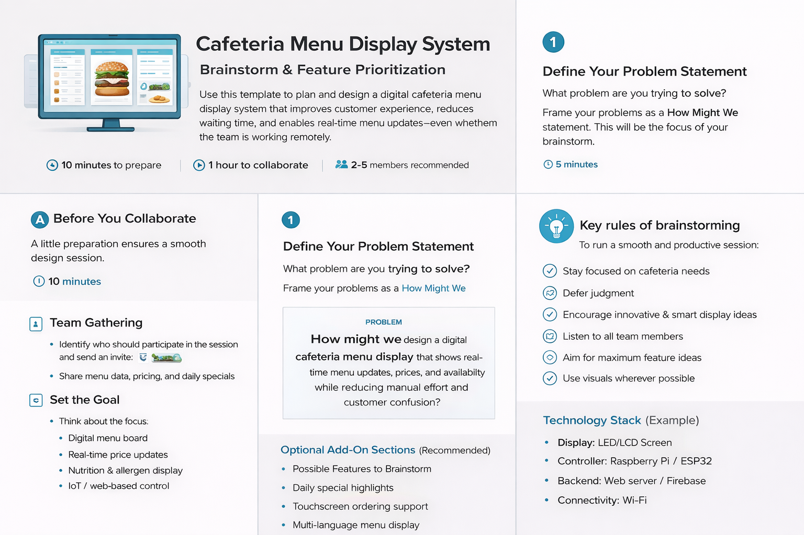

**Step-2: Brainstorm, Idea Listing and Grouping**

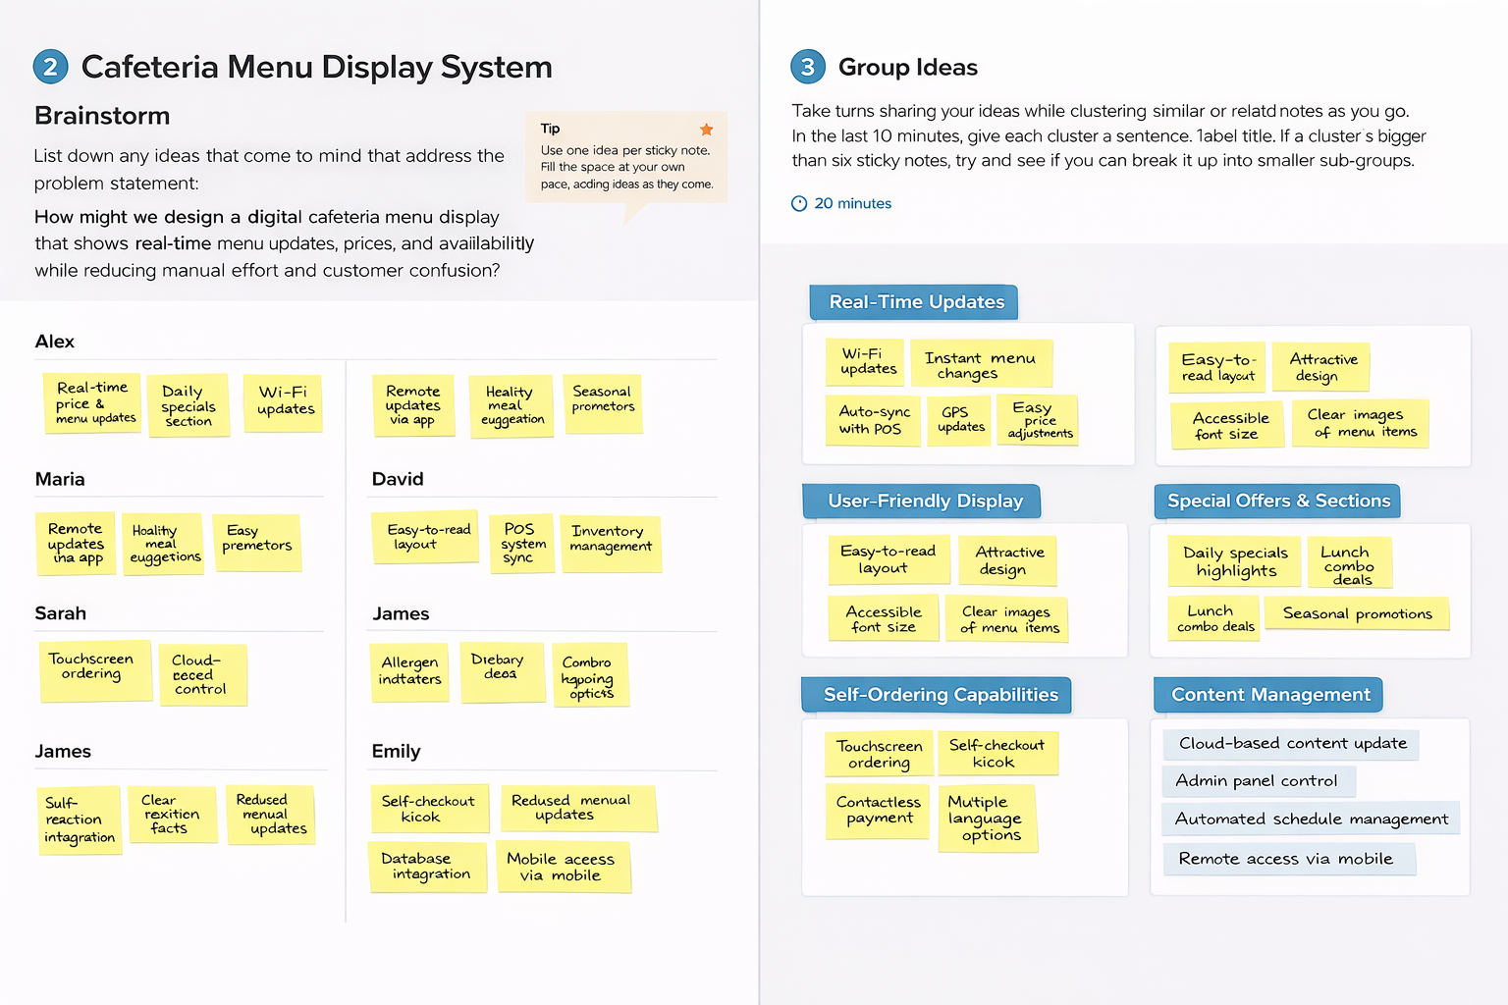

**Step-3: Idea Prioritization**